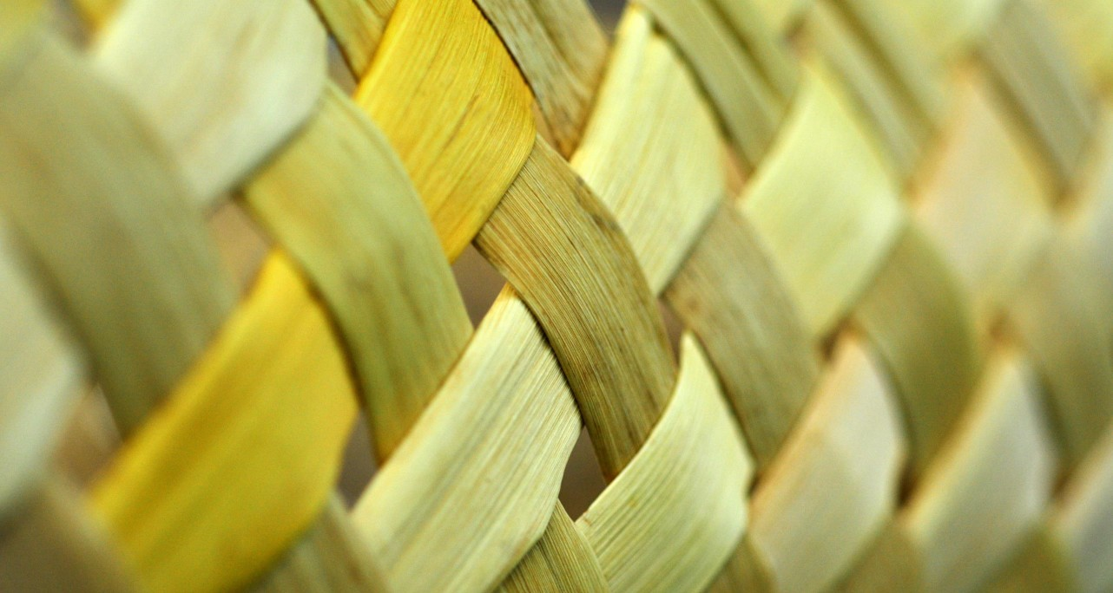


Pou Mokopuna | Intergenerational impact
What are your entity’s dependencies and impacts on te taiao? What are your priorities now and into the future? How is your entity balancing the resource allocation between generations?

Te Tumu | Interaction with the external world
What are the external factors that influence how we operate? How do we interact with the external environment?

Wāhi | Spaces to transition
What is our current reporting period? What did we commit to? What are the measures of success? What was successful, what was not? What got in the way?

Pou Tāhu | Strategic focus
What is our strategy? How is it being implemented? What are our values? What is our governance structure? How do we manage risk?

Pou Hononga | Ecosystem of connections
Who are our key relationships with? What is the nature of these relationships? How do we manage these connections?

Tūāpapa | Identity and purpose
Do we have a purpose? What is it?

Hunga whaipānga | Human and non-human parties
Who are our hunga whaipānga (human and non-human)? What do they expect of us?

Tāhuhu | Aspiration and vision
Do we have an aspiration or vision? Are we acting in alignment with it?

Pou Tuarongo | Institutional knowledge
How has institutional memory and historical experience shaped our values? Who were the influential people?

Refer to He Tauira and Mā te mahi for more in-depth questions.
Use this template as an introductory exercise to assist in overlaying concepts from He Tauira with your entity
He Tauira – stocktake template

